**ASSIGNMENT – 13**

**TOPIC: PRINCIPAL COMPONENT ANALYSIS (PCA)**

**Q.1. Try the same PCA with KNN model and check its accuracy.**

**Ans. 1) Before Applying PCA to our KNN model:**

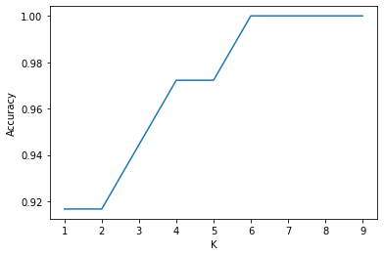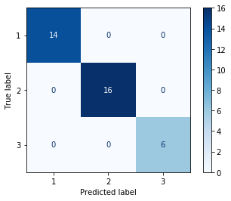

**Fig (a)- K vs Accuracy Fig (b)- Confusion matrix for k = 6**

Our KNN model shows that for k = 6 onwards it’s having accuracy score 1.00 which is 100%. And below that the accuracy is different for every different values of k ranging from 1 to 5.

**After Applying PCA to our KNN model:**

**PCA:** PCA is considered to be one of the most used unsupervised algorithms and can be seen as the most popular dimensionality reduction algorithm.

After anlysis of our pca.explained_variance_ratio_ i.e. ,

[0.36722576 0.19231879 0.10830194 0.07414597 0.06288414 0.05059778

0.0419487 0.02518069 0.02222384 0.01858596 0.01712304 0.01277985

0.00668354]

These 13 results that we get are the explained_variance_ratio_, out of these we can see that the first and the second results **0.36722576 0.19231879** consists of more of the percentage of the data. And since plotting the data in 2D space is easier to understand, we’ll use these two values which is total **0.55954439**‬ of the total data i.e., approx **56 %.**

Since, now that we know that these two are the most essential or we can say the principal components of our data. We can now train our KNN model.

After training our KNN model we get an accuracy score of **0.97222222** i.e., **97.22%.** Also our KNN model shows that (Fig c.) that for any value of K we are getting same accuracy result.

**Result after Applying PCA to our KNN model:**

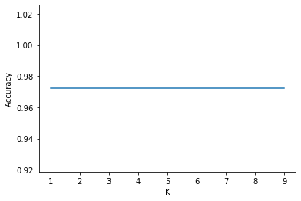 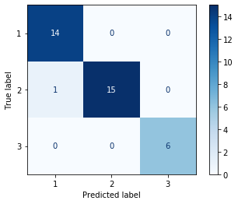

**Fig (c)- K vs Accuracy with PCA Fig (d)- Confusion matrix for any k**

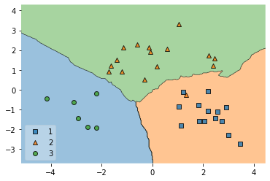

**Fid (e) – Decision Region with PCA KNN Model**